Why Did It Happen So ?

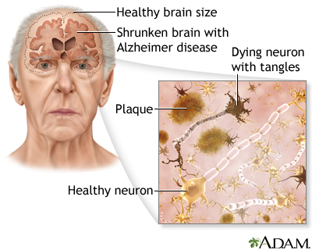
Like all types of dementia, Alzheimer's is caused by brain cell death. It is a neurodegenerative disease, which means there is progressive brain cell death that happens over time. In a person with Alzheimer's, the tissue has fewer and fewer nerve cells and connections.

